*****Kids’ Korner*****

RE-CHARGE – “High Seas Expedition” – Bring your friends to our awesome Wednesday night adventure! Dinner starts at 5:30 and the Expedition begins at 6:00. At 6:45, everyone will gather for a short worship service.
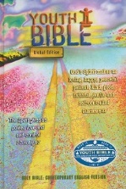
CHRISTMAS MUSICAL – We are very excited to begin practicing for our Christmas musical. We will rehearse on Wednesday evenings and Sunday mornings beginning on October 13. Please come and be a part of this; we have a great time! Invite your friends too !!!!

FAMILY EVENT – OCT. 26th – Irons Mill Farmstead
The HUM Education team is hosting an outing for the whole church family!!! We will be eating pizza at the church after Sunday school, and heading to New Wilmington, PA for an exciting adventure at Irons Mill Farmstead. There are activities for all ages, including hayrides, a pumpkin patch, Grandma Kettle’s Kitchen, Corn Cob beach, a corn maze and many, many more. There will be a sign up sheet in the Narthex and more details soon!!

NICODEMUS - October Rotation Sunday School
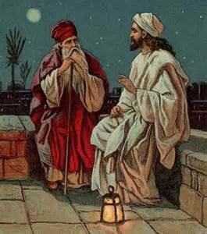
Can you see in the dark? Nicodemus looked for Jesus in the darkness. Do you ask questions? Jesus loved when people asked him questions. Come find out what Jesus had to say to this man of many questions. Bring your friends!!!

(After the Children’s Sermon, kids ages PK-6th grade are invited to the fellowship hall for a brief time of joint worship. From there, they are dismissed by grades to classrooms where they discover the Bible stories and God’s love through hands-on activities designed just for kids)!!!

THIRD GRADE BIBLES – If you have a child who is in third grade (or higher), we want to give him/her a Bible. Please give your child’s name the way you would like it to appear in his/her Bible to Debbie in the church office. We will be giving out the Bibles November 23.

NOVEMBER PREP MEETING FOR TEACHERS/SHEPHERDS
Prep meeting for November will be on Saturday, November 1, at 10:00 a.m. - please plan on attending to prepare materials and try out your lessons.

