*****Kids’ Korner*****

ZACCHAEUS - September Rotation Sunday School
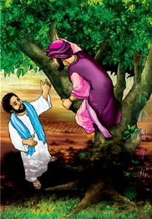
Do you like to climb trees? People in Bible times did!!! Join us as we learn about one of those men. We will play games, do puppet theatre, bake Zacchaeus cookies, do a drama and make a door hanger!! Bring your friends!!!

(After the Children’s Sermon, kids ages PK-6th grade are invited to the fellowship hall for a brief time of joint worship. From there, they are dismissed by grades to classrooms where they discover the Bible stories and God’s love through hands-on activities designed just for kids)!!!

OCTOBER PREP MEETING FOR TEACHERS/SHEPHERDS - Prep meeting for October will be on Saturday, October 4, at 9:30 a.m. - please plan on attending to prepare materials and try out your lessons.

RE-CHARGE – Be sure to watch for information about our Wednesday night program!!! We will be beginning this program in October – dinner is included!!!

THIRD GRADE BIBLES – If you have a child who is in third grade, we want to give him/her a Bible. Please give your child’s name to Debbie in the church office. We will be giving out the Bibles in October or November.

